**Piezoelectric for Energy Harvesting**

**TOOL OUTPUTS**

* **Input Acceleration**

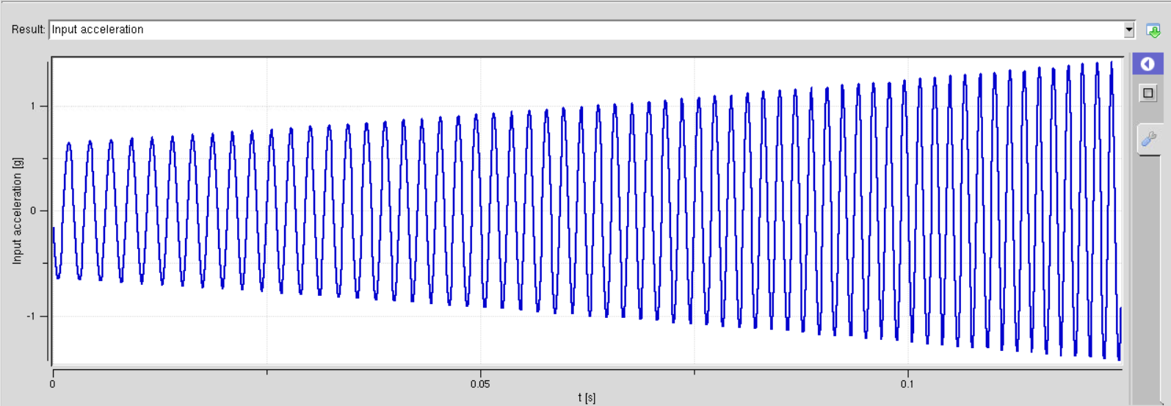

**Explanation:**

**Input Acceleration** represents the acceleration experienced by the device due to external mechanical vibrations or movements. For example, if the bimorph piezoelectric beam is part of a sensor attached to a vibrating surface, the input acceleration would measure the acceleration of that surface. This acceleration induces mechanical deformation in the piezoelectric material, leading to the generation of electrical voltage.

* **Voltage**

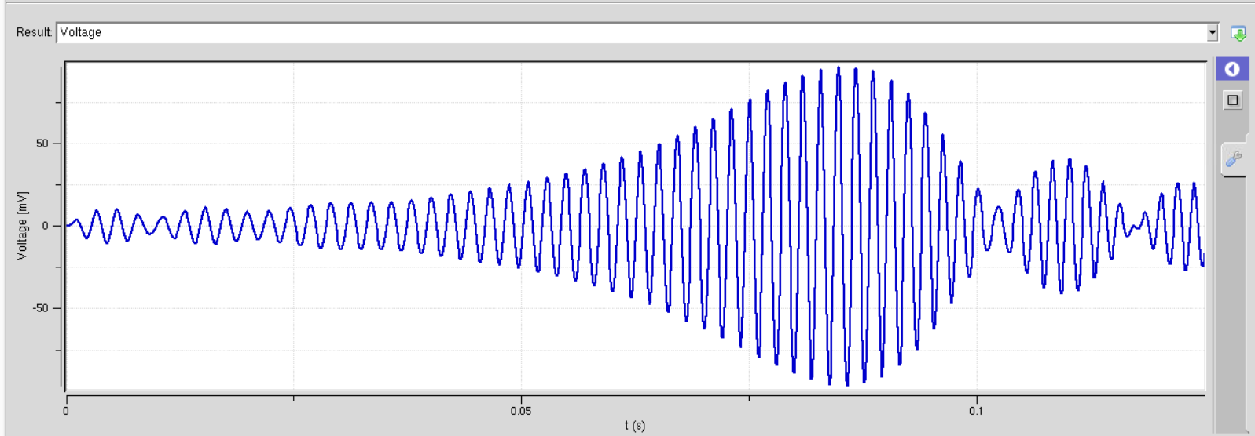

**Explanation:**

When a unimorph / bimorph piezoelectric beam is mechanically deformed (bent or subjected to vibrations), it induces a strain in the piezoelectric material. This strain results in a polarization of charges within the material, leading to the generation of an electrical voltage. The voltage generated is proportional to the applied mechanical stress or deformation.

* **Frequency Response Function**

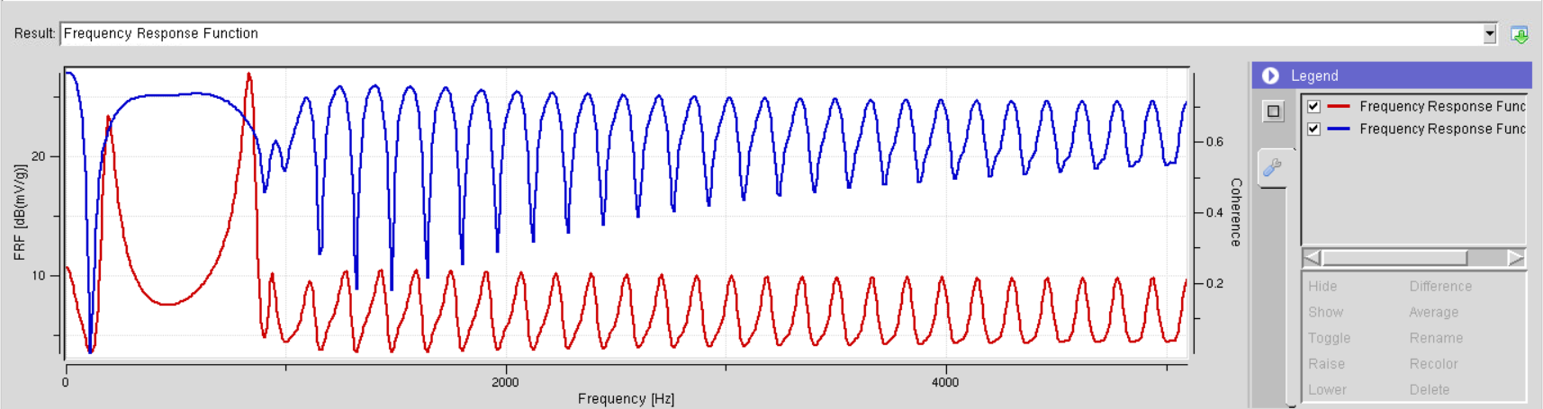

**Explanation:**

Peaks: These reveal the "sweet spots" where the harvester vibrates most readily and produces the highest voltage, called resonant frequencies. Think of them as the notes your harvester likes to play!

Shape: The overall smoothness indicates how readily the harvester responds to vibrations. A smooth curve means it readily captures energy across a range of frequencies, while a jagged curve suggests sensitivity to specific frequencies.

Coherence: This value tells you how reliable the data is. High coherence (close to 1) means the measurements are accurate, while low coherence suggests noise or other disturbances might be affecting the results.

* **Input – Output FFT**

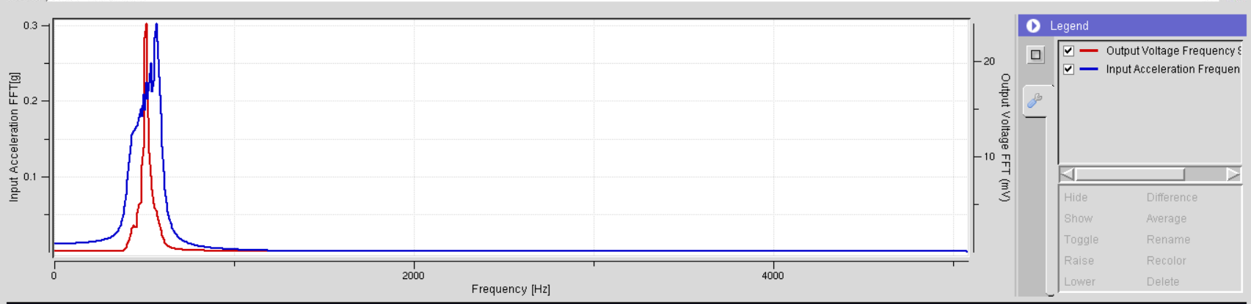

**Explanation:**

FFT (Fast Fourier Transform): It's a mathematical technique that breaks down a signal into its constituent frequencies, revealing the strength of each frequency component.

Input-Output Relationship: The output shows how the input acceleration (in g) at different frequencies is transformed into output voltage (in mV) by your piezoelectric MEMS energy harvester.

Identifying Dominant Frequencies: Examine the output to see which frequencies in the input acceleration have the most significant influence on the output voltage. These are likely the resonant frequencies of the harvester.

Understanding Frequency Response: Observe how the output voltage varies across different frequencies to assess the harvester's sensitivity and bandwidth.

**Input params of above graphs**

|  |  |
| --- | --- |
| **BEAM** | |
| **Geometry** | **Default** |
| Thickness of PIEZO | 265 um |
| Thickness of Substrate | 140 um |
| Length | 24.53 mm |
| Length of proof mass | 0.05mm |
| Width | 6.4 mm |
| Gap | 24mm |
| No. of piezo layers | 2 |
| Type of connection | Parallel |
|  |  |
| **Mechanical Properties** | **Default** |
| Proof of Mass | 1 mg |
| End mass density | 19000 kg/m3 |
| Mode | DB |
| Piezo | PZT-5H |
| Substrate | Brass |
|  |  |

|  |  |
| --- | --- |
| **VIBRATION** | |
| **Frequency Sweep** | **Default** |
| Start | 400 Hz |
| End | 600 Hz |
| Start Amplitude | 1 um |
| End Amplitude | 1 um |
| Exponential Decay Constant | 0 |
|  |  |
| **Random Vibrations** | **Default** |
| Expected amplitude of a random vibration | none |
|  |  |
| **Hammer Hit** | **Default** |
| Energy per Impulse | none |
| No. of hits | none |
|  |  |
| **Predetermined Vibrations** | **Default** |
| Common vibrations like 5 hp machine tool, washing machine, dryer | none |
|  |  |

|  |  |
| --- | --- |
| **OTHER PARAMETERS** | |
| **Environment** | **Default** |
| Temperature | 273K |
| Atmospheric Pressure | 101000Pa |
|  |  |
| **Circuit** | **Default** |
| Type of Circuit | Resistive |
| Load (R) | 7600Ohm |
| Load Capacitance | 10^(-6) F |
| Threshold Voltage | None |